Hi

I am looking at VBA coding from an importomatic profile created by my predecessor.

The import file is about Opt out where a supporter does not want to be contacted by us. We need to change it from consented email into Email Admin.

I need to know and understand how which area in the coding that commands VBA to change Email Type: from GST Consent Email into GST Admin Email as see Fig 2 and Fig 3. This happened after import sucessfully .

For Fig 1 is the import file ready for importomatic to Raisers Edge.

Fig 1
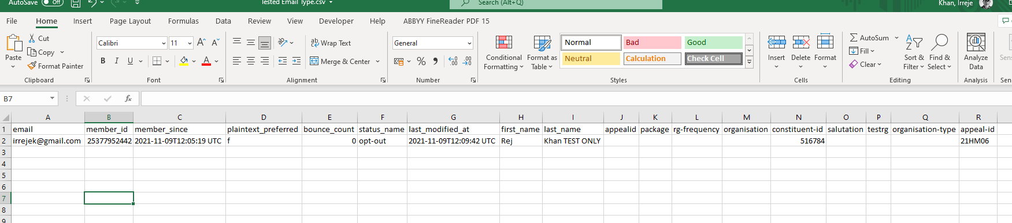

Fig 2

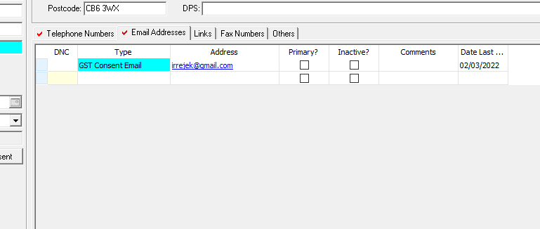

Fig 3

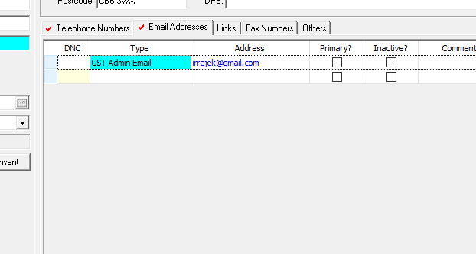

Fig 4

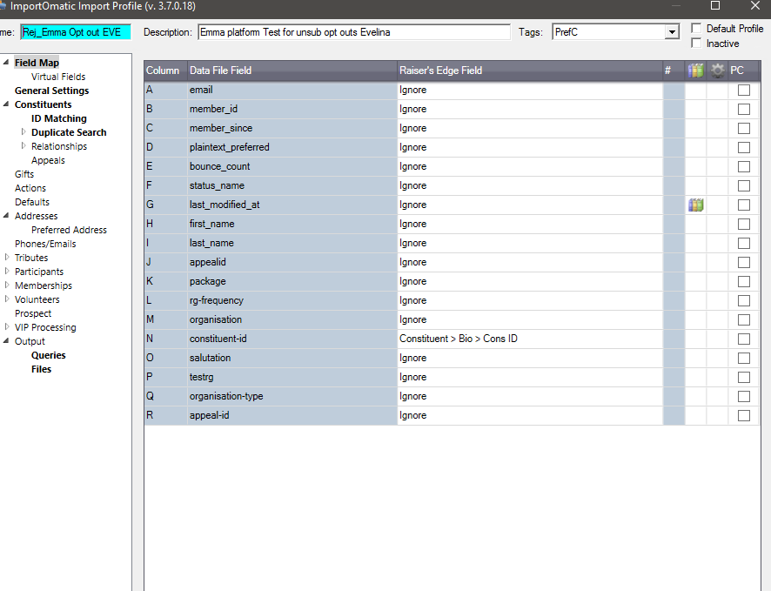

This VBA codes below from importomatic profile

If Instr(import.Fields.GetByName("status_name").Value,"opt-out",0) Then

Dim oPhonesParent As Blackbaud.PIA.RE7.BBREAPI.IBBPhonesParent
Dim oPs As Blackbaud.PIA.RE7.BBREAPI.CConstitPhones
Dim oP As Blackbaud.PIA.RE7.BBREAPI.IBBPhone
Dim fnd As Boolean
fnd = False

oPhonesParent = oRec
oPs = oPhonesParent.Phones
For Each oP In oPs
If UCASE(oP.Fields(Blackbaud.PIA.RE7.BBREAPI.EPhonesFields.Phone_fld_Num)) = UCASE(import.Fields.GetByName("email").Value) Then
'oPs.Remove(oP)
Call Globalcode.deleteNumber(oRec,oP.Fields(Blackbaud.PIA.RE7.BBREAPI.EPhonesFields.Phone_fld_Id))
End if
Next oP

Dim oAct As New Blackbaud.PIA.RE7.BBREAPI.CAction
oAct.Init(Import.SessionContext)
oAct.Fields(Blackbaud.PIA.RE7.BBREAPI.EACTIONFields.ACTION_fld_RECORDS_ID) = oRec.Fields(Blackbaud.PIA.RE7.BBREAPI.ERECORDSFields.RECORDS_fld_ID)
oAct.Fields(Blackbaud.PIA.RE7.BBREAPI.EACTIONFields.ACTION_fld_CATEGORY) = "Task/Other"
oAct.Fields(Blackbaud.PIA.RE7.BBREAPI.EACTIONFields.ACTION_fld_TYPE) = "Unsubscribe/Bounce Import"
oAct.Fields(Blackbaud.PIA.RE7.BBREAPI.EACTIONFields.ACTION_fld_STATUS) ="Received"
oAct.Fields(Blackbaud.PIA.RE7.BBREAPI.EACTIONFields.ACTION_fld_DATE) =import.Fields.GetByName("last_modified_at").value
oAct.Fields(Blackbaud.PIA.RE7.BBREAPI.EACTIONFields.ACTION_fld_COMPLETED) = True
oAct.Fields(Blackbaud.PIA.RE7.BBREAPI.EACTIONFields.ACTION_fld_COMPLETED_DATE) =import.Fields.GetByName("last_modified_at").value

With oAct.Attributes.Add()
.Fields(Blackbaud.PIA.RE7.BBREAPI.EattributeFields.Attribute_fld_ATTRIBUTETYPES_ID) =1124
.Fields(Blackbaud.PIA.RE7.BBREAPI.EattributeFields.Attribute_fld_VALUE) = "Guy's & St Thomas' Charity Record"
.Fields(Blackbaud.PIA.RE7.BBREAPI.EattributeFields.Attribute_fld_ATTRIBUTEDATE) =import.Fields.GetByName("last_modified_at").value
End With

With oAct.Attributes.Add
.Fields(Blackbaud.PIA.RE7.BBREAPI.EattributeFields.Attribute_fld_ATTRIBUTETYPES_ID) = 117
.Fields(Blackbaud.PIA.RE7.BBREAPI.EattributeFields.Attribute_fld_VALUE) = import.Fields.GetByName("appeal-id").Value
.Fields(Blackbaud.PIA.RE7.BBREAPI.EattributeFields.Attribute_fld_ATTRIBUTEDATE) =import.Fields.GetByName("last_modified_at").value
End With

With oAct.Attributes.Add
.Fields(Blackbaud.PIA.RE7.BBREAPI.EattributeFields.Attribute_fld_ATTRIBUTETYPES_ID) = 1162
.Fields(Blackbaud.PIA.RE7.BBREAPI.EattributeFields.Attribute_fld_VALUE) = import.Fields.getbyname("email").value
.Fields(Blackbaud.PIA.RE7.BBREAPI.EattributeFields.Attribute_fld_ATTRIBUTEDATE) =import.Fields.GetByName("last_modified_at").value
End With
'ADD SOURCE
With oAct.Attributes.Add()
.Fields(Blackbaud.PIA.RE7.BBREAPI.EattributeFields.Attribute_fld_ATTRIBUTETYPES_ID) = 1297
.Fields(Blackbaud.PIA.RE7.BBREAPI.EattributeFields.Attribute_fld_VALUE) = "Emma"
.Fields(Blackbaud.PIA.RE7.BBREAPI.EattributeFields.Attribute_fld_ATTRIBUTEDATE) = import.Fields.GetByName("last_modified_at").value
End With

oAct.Save

oAct.CloseDown

Call Globalcode.AddNumber(oRec,import.Fields.getbyname("email").value,"GST","No")

End if

End Sub

Thank you

Regards

Rej

